

**New voluntary service for parents** Consultation approach

The department is leading the consultation process to design a new, voluntary service that supports parents who care for young children. The new service will be for parents who receive a Parenting Payment. It will help them to:

* plan for their future education and employment goals
* build their capabilities and skills
* work toward the type of paid work they want, when they’re ready.

We will work in partnership with key agencies and community organisations to undertake a multi-pronged engagement approach.

The engagement will be iterative with consultations running simultaneously to ensure we capture a range of perspectives and design ideas across our stakeholders in a limited timeframe.

# The approach has four phases

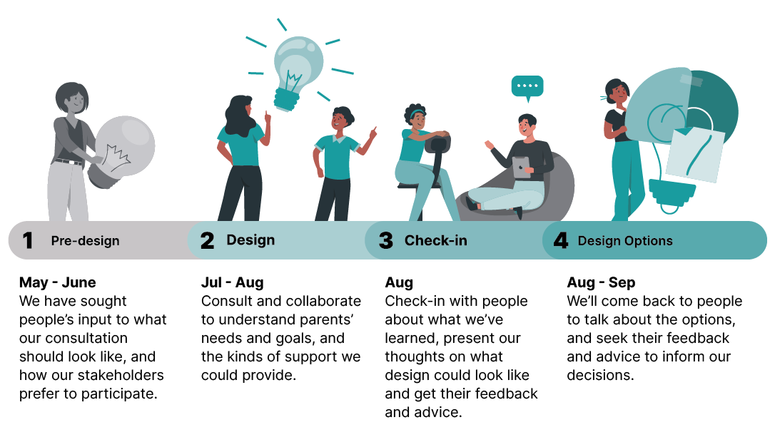

| **Pre-Design** | **Design** | **Check-In and Early Direction** | **Design Options** |
| --- | --- | --- | --- |
| **May-June** | **Jul-Aug** | **Aug** | **Aug-Sept** |
| We have sought people’s input to what our consultation should look like, and how our stakeholders prefer to participate. | Consult and collaborate to understand parents’ needs and goals, and the kind of supports we could provide. | Check-in with people about what we’ve learned, present our thoughts on what design could look like and get their feedback and advice. | We’ll come back to people to talk about options, and seek their feedback and advice to inform our decisions |

# Who are we talking to?

We are talking to a range of stakeholders relevant to this process, beginning with parents. Each stakeholder stream has a targeted approach of engagement. Engagement across stakeholder groups will occur concurrently, both directly and in partnership with community organisations.

|  |  |  |  |
| --- | --- | --- | --- |
| **Past and Present Participants** | **First Nations** | **People with Disability** | **Migrant and Refugee** |
| Youth | **Women at risk** | **Community Groups** | **Peaks** |
| Providers | **Employers** | **Public** |  |

## Past and present participants (survey and workshops with past and present participants)

***Note:*** *all locations are subject to confirmation and change, depending on take-up of invitations to workshops and confirmation of venues*

| **Who** | **How** | **When** |
| --- | --- | --- |
| DEWR – Applied Behavioural Insights team | Call out survey and phone call inviting past and present ParentsNext participants to participate in workshops. | Early July |
| DEWR – Applied Behavioural Insights team | Phase 2 workshops with volunteer past and present ParentsNext participants:   * Bankstown NSW * Brisbane QLD * Virtual | July |
| DEWR – Applied Behavioural Insights team (in consultation with Services Australia) | Phase 3 survey of past and present ParentsNext participants to test options and seek feedback on consultations. | August |
| DEWR – Applied Behavioural Insights team | Phase 4 workshops with volunteer past and present ParentsNext participants   * Perth WA * Hobart TAS * Virtual | August/September |

## Potential participants (workshop with parenting payment recipients)

***Note****: all locations are subject to confirmation and change, depending on take-up of invitations to workshops and confirmation of venues.*

| **Who** | **How** | **When** |
| --- | --- | --- |
| Services Australia | SMS/Email/Phone call inviting Parenting Payment recipients to participate in workshops. | July |
| Services Australia | Phase 2 workshops with volunteer Parenting Payment participants:   * Melbourne VIC * Toowoomba QLD * Canberra ACT | July |
| DEWR – Applied Behavioural Insights team | Phase 3 survey of participants to test options and seek feedback on consultations. | August |

## Targeted workshops with lived experience in key locations (face to face and virtual)

***Note****: all locations are subject to confirmation and change, depending on take-up of invitations to workshops and confirmation of venues.*

| **Cohorts** | **How** | **Locations** | **When** |
| --- | --- | --- | --- |
| Women | Partnership with community organisations | * Sydney/regional NSW * Brisbane/regional QLD * Adelaide/regional SA * Shepparton VIC | July/August |
| First Nations | Specialist First Nations Facilitator  Partnership with community organisation | * Tamworth NSW * Blacktown NSW * Perth WA * Yarrabah QLD * Cairns QLD | July/August |
| Migrant and Refugee | Partnership with community organisation | * Adelaide SA * Mirrabooka WA * Prahran VIC * Logan Central QLD * Blacktown NSW | July/August |
| People with Disability | Partnership with community organisation | * Sydney/regional NSW * Brisbane/regional QLD * Adelaide/regional SA * Melbourne/regional VIC | July/August |
| Youth | Partnership with community organisation | * Burnie TAS * Newcastle NSW * Geelong VIC * Corio VIC * Virtual | July/August |
|  | Collaboration with Office for Youth | * Virtual | July/August |

#### Community Groups, Peaks, Other

* Relevant and representative community groups identified through previous submissions to the ParentsNext Inquiry and broad stakeholder analysis of high interest groups and individuals.
* Pre-design discussions held with community and advocacy groups.
* Testing of consultation approach and scope and framing of discussion topics and questions.
* Targeted small procurement to support co-facilitation with trusted community partners for direct public participation in co-design.
* Options feedback presented via community group and direct contact with participants (if they indicate they would like to receive follow-up information).
* Roundtables with peaks, academics, service deliverers.

## Businesses

| **Who** | **How** | **When** |
| --- | --- | --- |
| DEWR - National Workforce Solutions Branch | Virtual outreach through Employment Liaison Officers; meetings with Industry peaks | July - August |

## Providers

| **Who** | **How** | **When** |
| --- | --- | --- |
| Employment Services peak bodies | Early meetings for feedback in developing consultation approach | June |
| Employment Services peak bodies | Feedback on all consultations and options, virtual roundtables | July - August |
| Current ParentsNext Providers | Feedback on all consultations and options | 29 August, Workforce Australia National Forum |

## State and Territory Government

| **Who** | **How** | **When** |
| --- | --- | --- |
| State and Territory Government Representatives | Information sharing | July - August |